**Day-4. Assignment on structures**

**1.** Write C program to accept the details of employee and display them using structure. Details consist of Employee ID, Name, Designation, Department, and Salary.

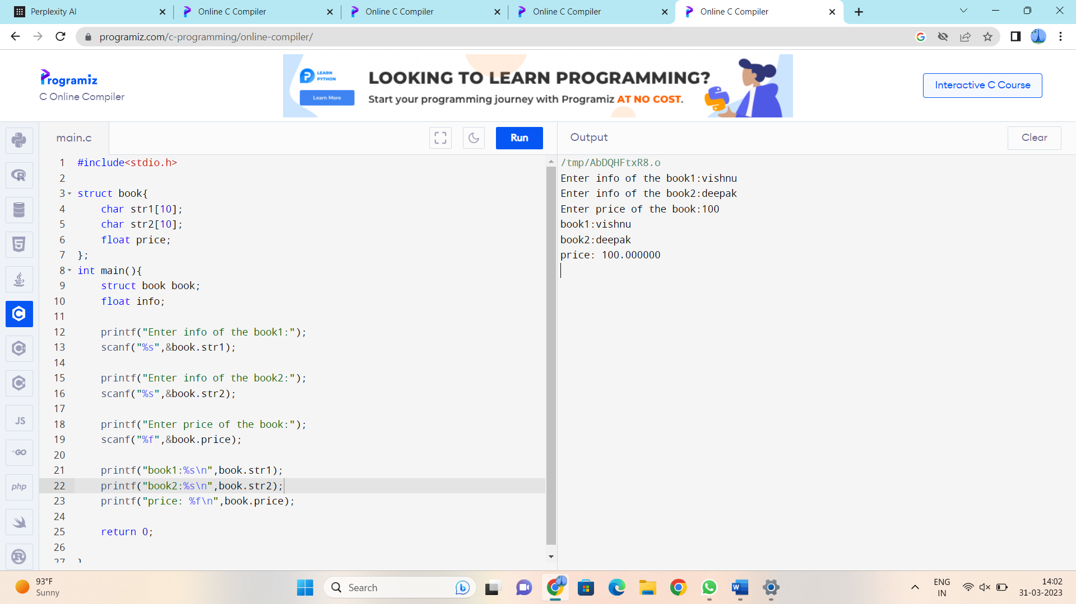

2. Write C program to accept batting information of cricket team using structure. It contains player name and runs scored by player. Calculate total runs scored by cricket team.

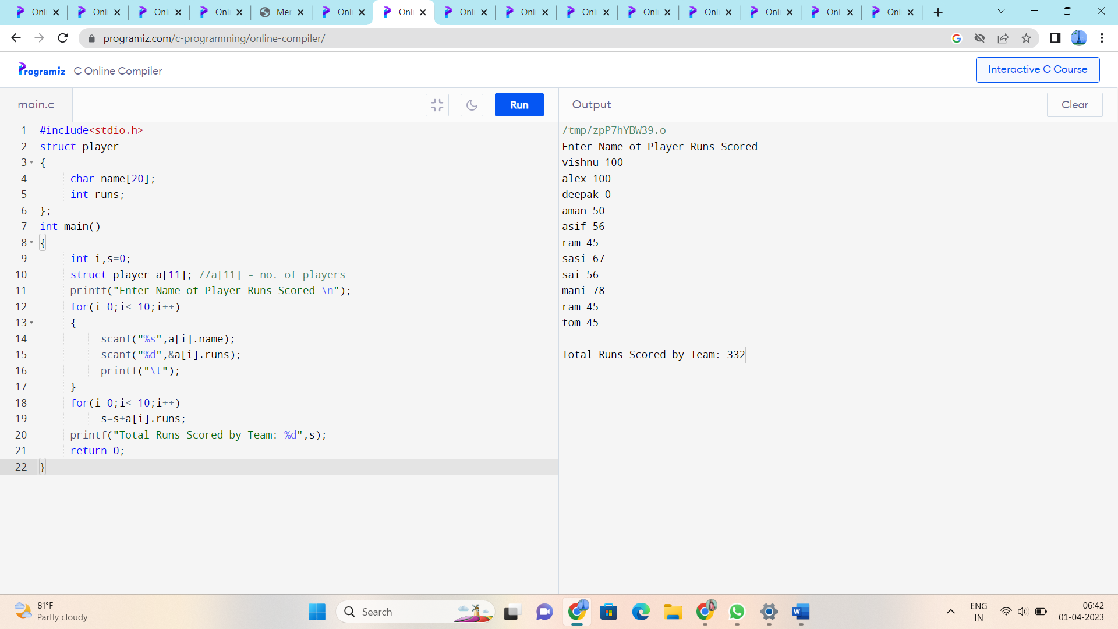

3. C program to read information of student. It contains Name, Roll number, Birthday, admission date. Calculate age of student at the time of admission.

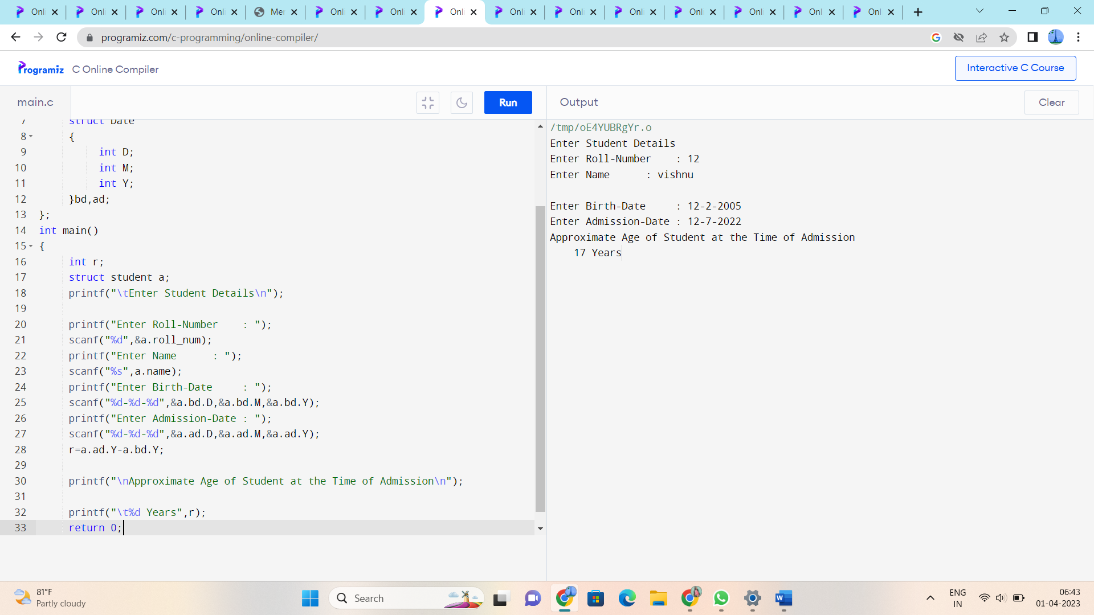

4. Write a 'C' program to accept customer details such as: Account_no, Name, Balance using structure. Assume 3 customers in the bank. Write a function to print the account no. and name of each customer whose balance < 100 Rs.

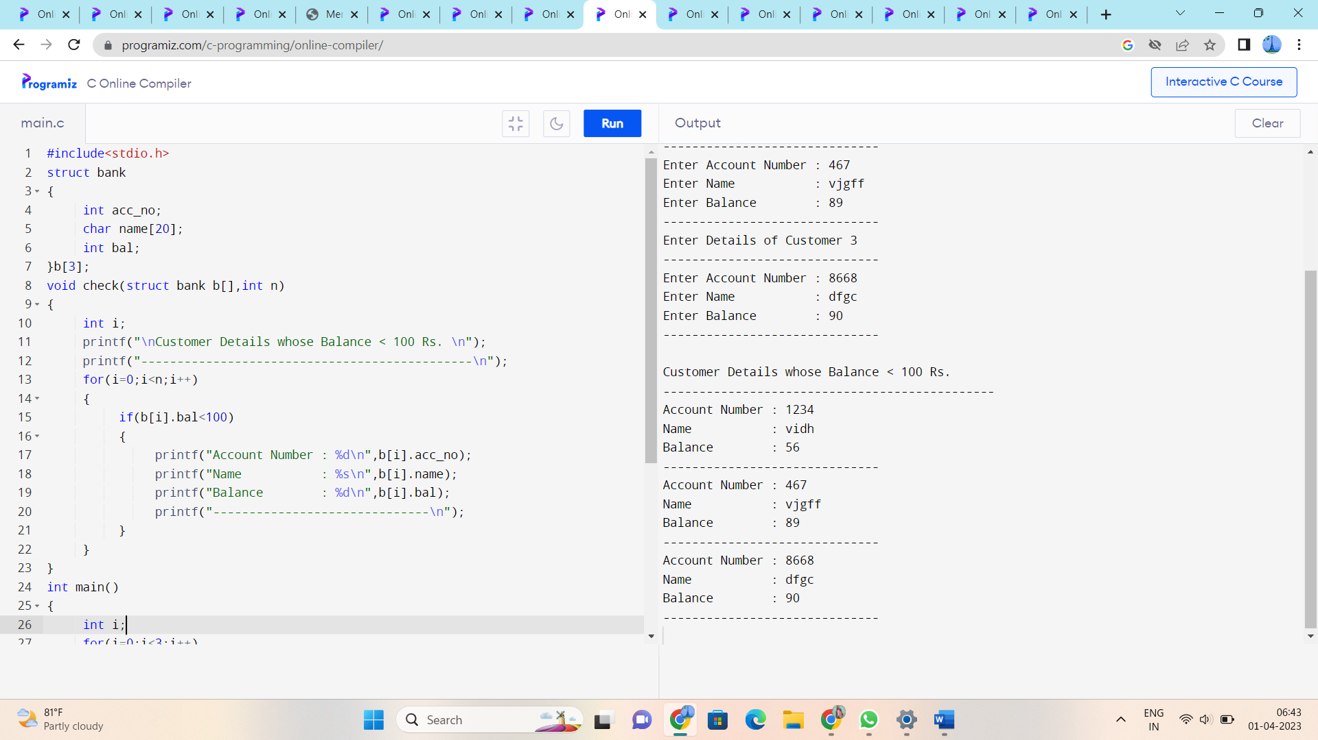

**5.** Write a 'C' program to accept customer details such as: Account_no, Name, Balance using structure. Assume 3 customers in the bank. Write a function to print the account no. and name of each customer whose balance < 100 Rs.

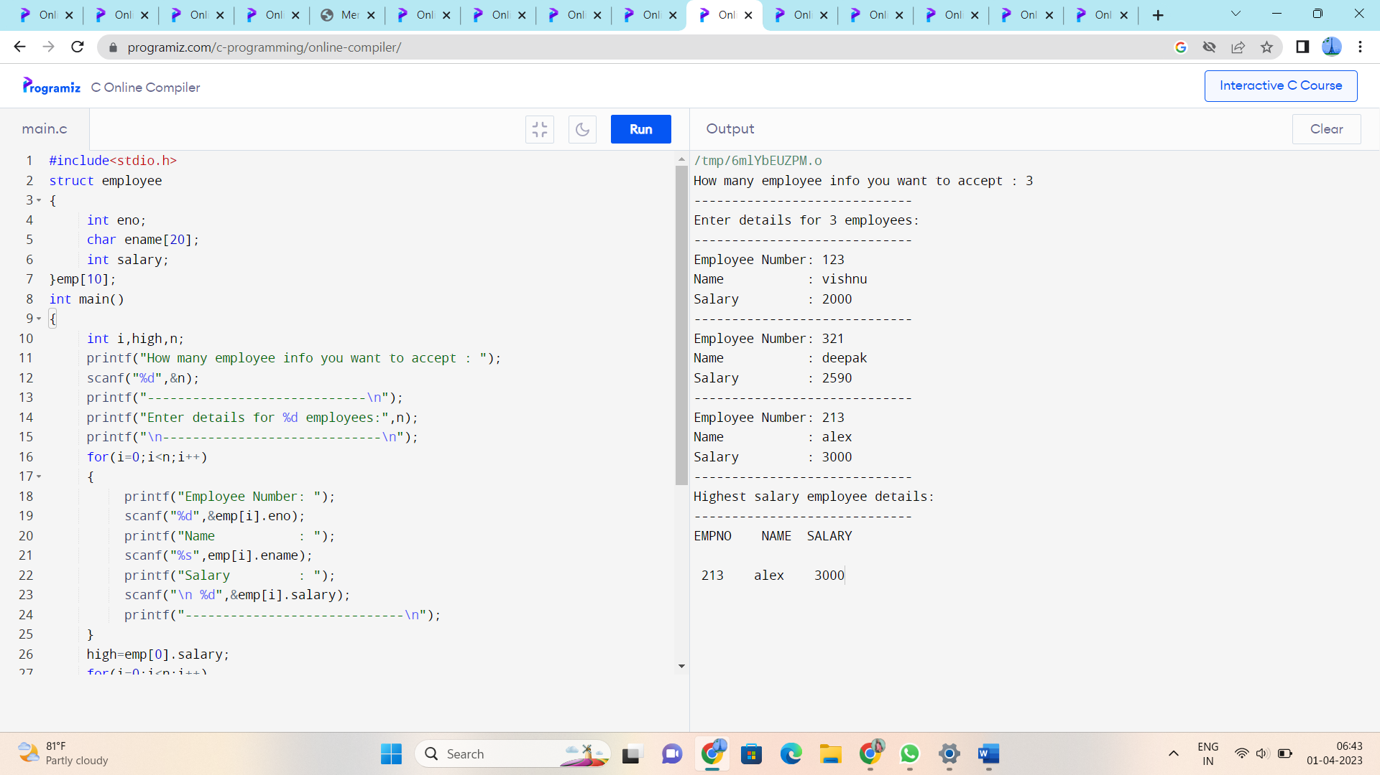

6. Write a menu driven program in 'C' which shows the working of library. The menu option should be  
i) Add book details.  
ii) Display book details.  
iii) List all books of given author.  
iv) List the count of books in the library.  
v) Exit.

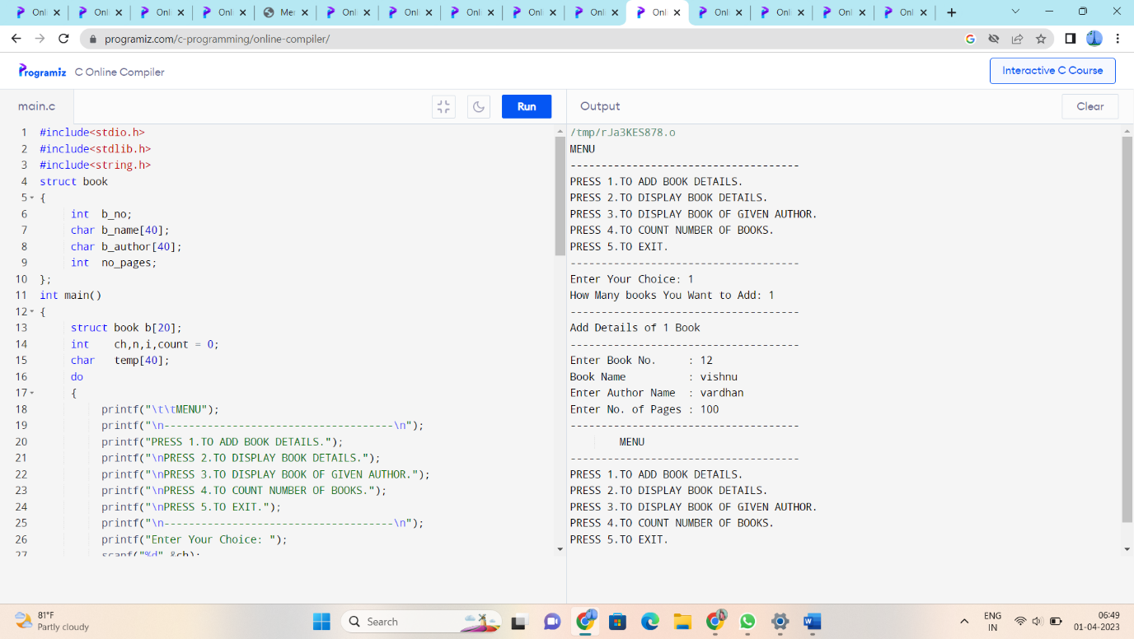

7. Write a 'C' Program to create a structure of student having fields roll_no, stud_name, mark1, mark2, mark3. Calculate total marks and average marks. Arrange the records in descending order of marks.

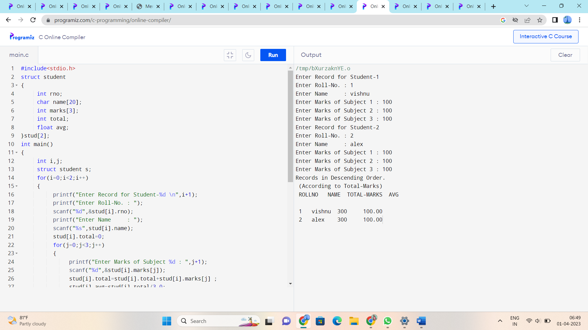

8. Write a program that declares a union variable data that can store an integer or a float value. Prompt the user to enter a value of their choice and store it in the appropriate member of the union. Then, print the value that was entered.

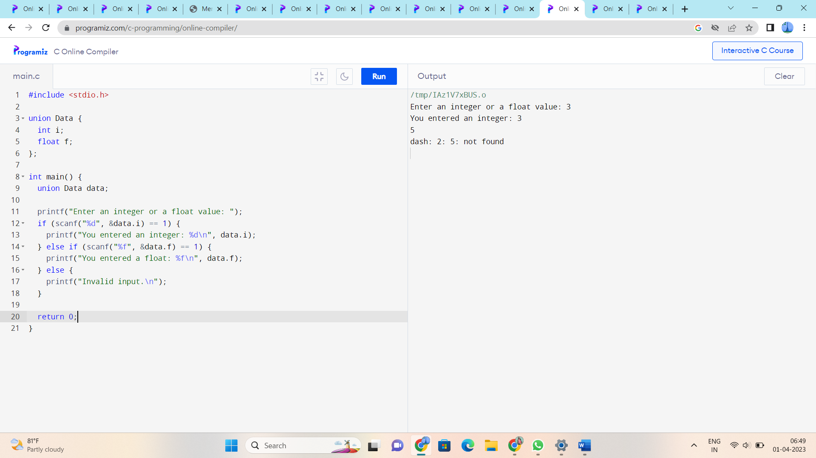

9. Create a program that defines a union student that can store a student's name (up to 50 characters) and their GPA. Prompt the user to enter the student's name and GPA, and store them in the union. Then, print the student's name and GPA.

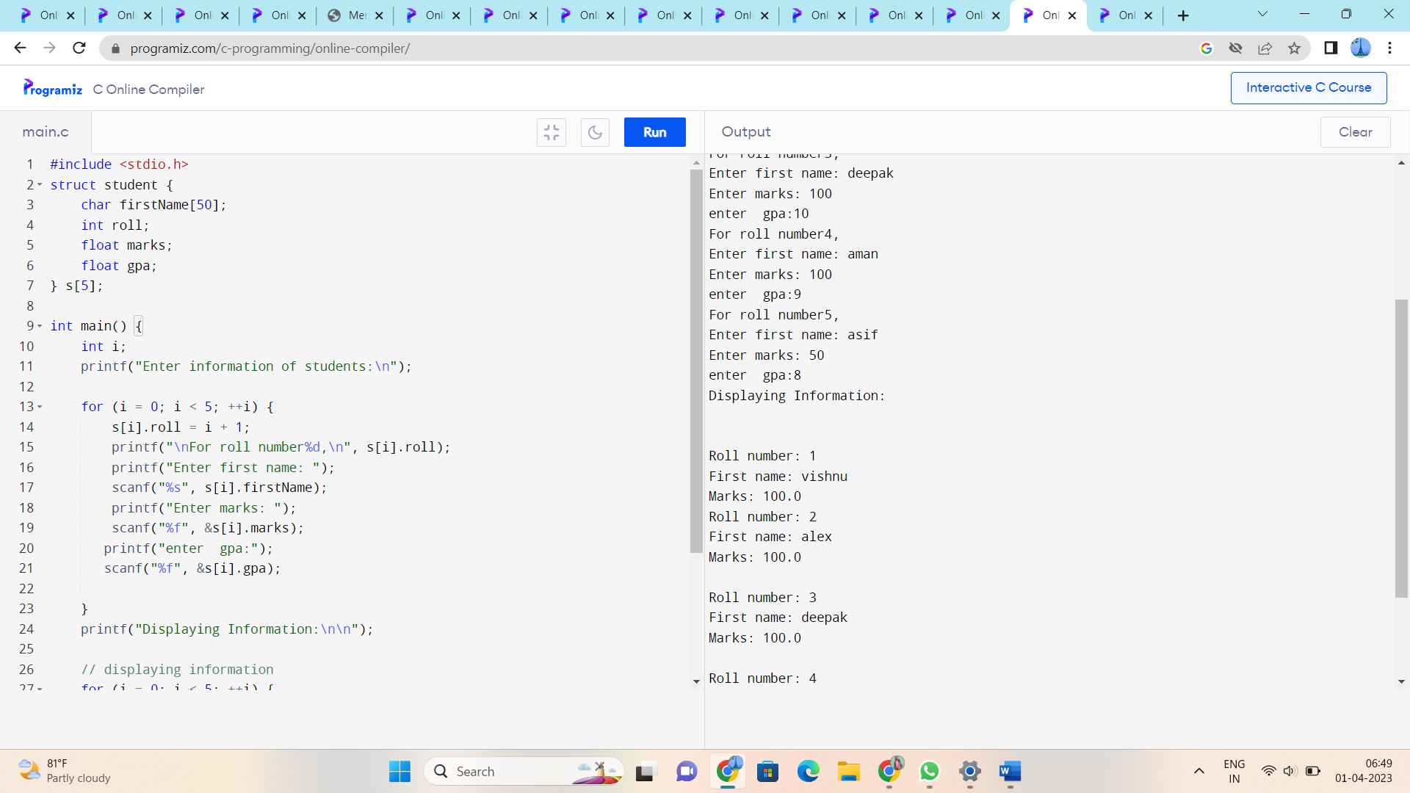

10. Write a program that defines a union shape that can store a circle's radius or a rectangle's length and width. Prompt the user to enter the type of shape they want to calculate (circle or rectangle), and then prompt them to enter the appropriate dimensions. Calculate and print the area of the shape they entered.

